**Work Breakdown Structure (WBS)**

**RAM-IT: ITRO’s ChatBot & Ticketing System**

**Asia Pacific College**

**3 Humabon Place, Magallanes**

**Makati City 1232 PH**

**May. 03, 2023**

# Introduction

The Work Breakdown Structure shows the Summary Tasks and Work Packages that are needed to be done through the whole process of the project RAM-IT: ITRO’s ChatBot & Ticketing System.

# Outline View

1. RAM-IT: ITRO’s ChatBot & Ticketing System
   1. Initiation
      1. Design Thinking
      2. Create Business Case
      3. Create Project Charter
      4. Project Sponsor Approval of Project
      5. Assign Project Team & Roles
      6. Identify Stakeholders
   2. Planning
      1. First Meeting with Project Team
      2. Create Stakeholders Management Strategy Plan
      3. Create Cost Management Plan
      4. Create Scope Management Plan
      5. Create Time Management Plan
      6. Create Work Breakdown Structure
      7. Create Human Resource Management Plan
      8. Create Quality Management Plan
      9. Create Risk Management Plan
      10. Create Communications Management Plan
      11. Create Procurement Management Plan
      12. Create Implementation Plan
      13. Create Change Management Plan
      14. Meeting for Documents Development
      15. Send Documents for Project Sponsor Approval
   3. Execution
      1. Analysis & Design
         1. Develop Requirements Analysis
         2. Develop System Analysis
         3. Create System Design
         4. Create System Wireframe
         5. Create System Mock-Up
      2. Development
         1. Develop Log-In Feature
         2. Develop Chat Bot Feature
         3. Develop Ticketing Feature
         4. Develop Notification Feature
         5. Develop Data Report Feature
         6. Develop Filter Feature
         7. Develop Ticket History Feature
         8. Develop Chat Feature
         9. Implement UI
      3. Testing & Training
         1. Install System
         2. Perform Test Cases
         3. Training the ITRO
   4. Monitoring & Control
      1. Gather Feedback Data
      2. Risk Manage
      3. Monitor if Project Deliverables are complying to Project Documents
      4. Weekly Status Report
   5. Completion/Closeout
      1. Transferring roles to ITRO
      2. Transferring deliverables to ITRO
      3. Archiving Documents
      4. Final Meeting
      5. Confirmation of User Acceptance
      6. Confirmation of Project Completion

# Hierarchical Structure

|  |  |  |
| --- | --- | --- |
| Level | WBS Code | Element Name |
| 1 | 1 | RAM-IT: ITRO’s ChatBot & Ticketing System |
| 2 | 1.1 | Initiation |
| 3 | 1.1.1 | Design Thinking |
| 3 | 1.1.2 | Create Business Case |
| 3 | 1.1.3 | Create Project Charter |
| 3 | 1.1.4 | Project Sponsor Approval of Project |
| 3 | 1.1.5 | Assign Project Team & Roles |
| 3 | 1.1.6 | Identify Stakeholders |
| 2 | 1.2 | Planning |
| 3 | 1.2.1 | First Meeting with Project Team |
| 3 | 1.2.2 | Create Stakeholders Management Strategy Plan |
| 3 | 1.2.3 | Create Cost Management Plan |
| 3 | 1.2.4 | Create Scope Management Plan |
| 3 | 1.2.5 | Create Time Management Plan |
| 3 | 1.2.6 | Create Work Breakdown Structure |
| 3 | 1.2.7 | Create Human Resource Management Plan |
| 3 | 1.2.8 | Create Quality Management Plan |
| 3 | 1.2.9 | Create Risk Management Plan |
| 3 | 1.2.10 | Create Communications Management Plan |
| 3 | 1.2.11 | Create Procurement Management Plan |
| 3 | 1.2.12 | Create Implementation Plan |
| 3 | 1.2.13 | Create Change Management Plan |
| 3 | 1.2.14 | Meeting for Documents Development |
| 3 | 1.2.15 | Send Documents for Project Sponsor Approval |
| 2 | 1.3 | Execution |
| 3 | 1.3.1 | Analysis & Design |
| 4 | 1.3.1.1 | Develop Requirements Analysis |
| 4 | 1.3.1.2 | Develop System Analysis |
| 4 | 1.3.1.3 | Create System Design |
| 4 | 1.3.1.4 | Create System Wireframe |
| 4 | 1.3.1.5 | Create System Mock-Up |
| 3 | 1.3.2 | Development |
| 4 | 1.3.2.1 | Develop Log-In Feature |
| 4 | 1.3.2.2 | Develop Chat Bot Feature |
| 4 | 1.3.2.3 | Develop Ticketing Feature |
| 4 | 1.3.2.4 | Develop Notification Feature |
| 4 | 1.3.2.5 | Develop Data Report Feature |
| 4 | 1.3.2.6 | Develop Filter Feature |
| 4 | 1.3.2.7 | Develop Ticket History Feature |
| 4 | 1.3.2.8 | Develop Chat Feature |
| 4 | 1.3.2.9 | Implement UI |
| 3 | 1.3.3 | Testing & Training |
| 4 | 1.3.3.1 | Install System |
| 4 | 1.3.3.2 | Perform Test Cases |
| 4 | 1.3.3.3 | Training the ITRO |
| 2 | 1.4 | Monitoring & Control |
| 3 | 1.4.1 | Gather Feedback Data |
| 3 | 1.4.2 | Risk Manage |
| 3 | 1.4.3 | Monitor if Project Deliverables are complying to Project Documents |
| 3 | 1.4.4 | Weekly Status Report |
| 2 | 1.5 | Completion/Closeout |
| 3 | 1.5.1 | Transferring roles to ITRO |
| 3 | 1.5.2 | Transferring deliverables to ITRO |
| 3 | 1.5.3 | Archiving Documents |
| 3 | 1.5.4 | Final Meeting |
| 3 | 1.5.5 | Confirmation of User Acceptance |
| 3 | 1.5.6 | Confirmation of Project Completion |

# Tabular View

|  |  |  |  |
| --- | --- | --- | --- |
| Level 1 | Level 2 | Level 3 | Level 4 |
| 1 RAM-IT: ITRO’s ChatBot & Ticketing System | 1.1 Initiation | 1.1.1 Design Thinking  1.1.2 Create Business Case  1.1.3 Create Project Charter  1.1.4 Project Sponsor Approval of Project  1.1.5 Assign Project Team & Roles  1.1.6 Identify Stakeholders |  |
| 1.2 Planning | 1.2.1 First Meeting with Project Team  1.2.2 Create Stakeholders Management Strategy Plan  1.2.3 Create Cost Management Plan  1.2.4 Create Scope Management Plan  1.2.5 Create Time Management Plan  1.2.6 Create Work Breakdown Structure  1.2.7 Create Human Resource Management Plan  1.2.8 Create Quality Management Plan  1.2.9 Create Risk Management Plan  1.2.10 Create Communications Management Plan  1.2.11 Create Procurement Management Plan  1.2.12 Create Implementation Plan  1.2.13 Create Change Management Plan  1.2.14 Meeting for Documents Development  1.2.15 Send Documents for Project Sponsor Approval |  |
| 1.3 Execution | 1.3.1 Analysis & Design | 1.3.1.1 Develop Requirements Analysis  1.3.1.2 Develop System Analysis  1.3.1.3 Create System Design  1.3.1.4 Create System Wireframe  1.3.1.5 Create System Mock-Up |
| 1.3.2 Development | 1.3.2.1 Develop Log-In Feature  1.3.2.2 Develop Chat Bot Feature  1.3.2.3 Develop Ticketing Feature  1.3.2.4 Develop Notification Feature  1.3.2.5 Develop Data Report Feature  1.3.2.6 Develop Filter Feature  1.3.2.7 Develop Ticket History Feature  1.3.2.8 Develop Chat Feature  1.3.2.9 Implement UI |
| 1.3.3 Testing & Training | 1.3.3.1 Install System  1.3.3.2 Perform Test Cases  1.3.3.3 Training the ITRO |
| 1.4 Monitoring & Control | 1.4.1 Gather Feedback Data  1.4.2 Risk Manage  1.4.3 Monitor if Project Deliverables are complying to Project Documents  1.4.4 Weekly Status Report |  |
| 1.5 Completion/Closeout | 1.5.1 Transferring roles to ITRO  1.5.2 Transferring deliverables to ITRO  1.5.3 Archiving Documents  1.5.4 Final Meeting  1.5.5 Confirmation of User Acceptance  1.5.6 Confirmation of Project Completion |

# Tree Structure View

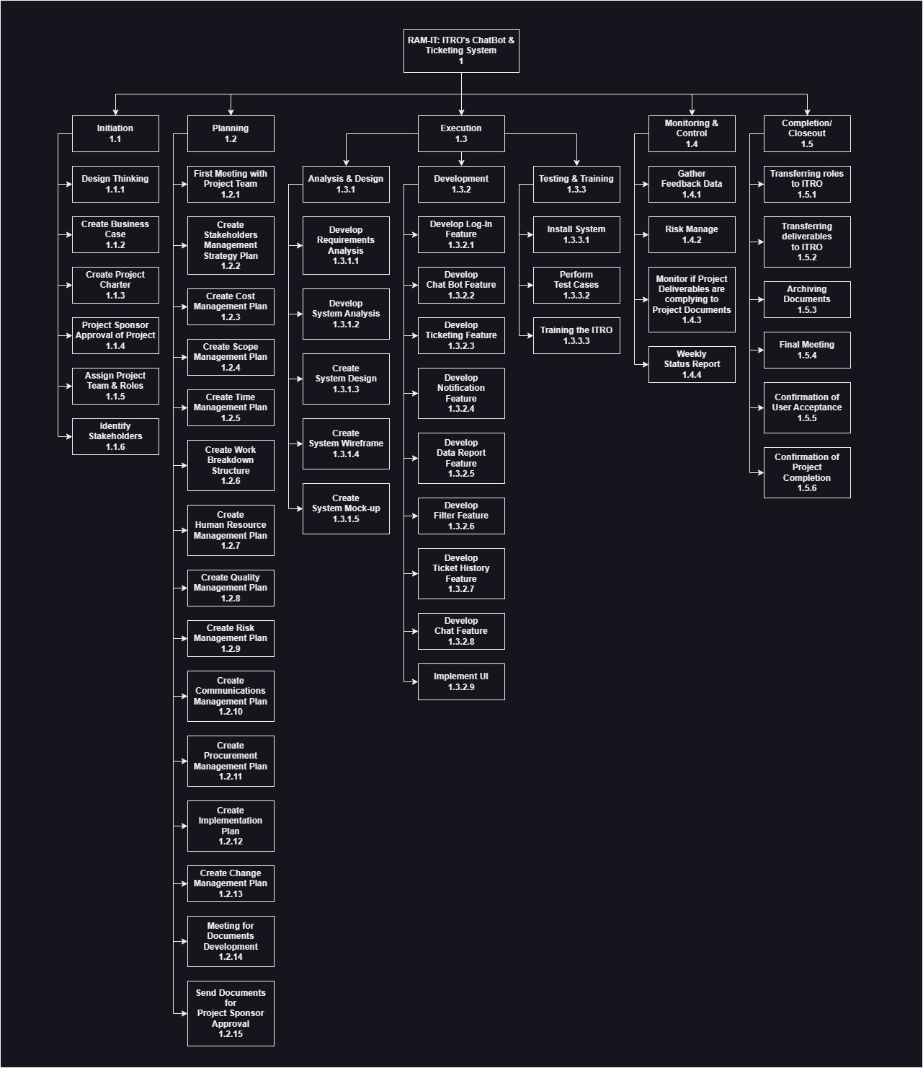

# WBS Dictionary

| Level | WBS Code | Element Name | Definition |
| --- | --- | --- | --- |
| 1 | 1 | RAM-IT: ITRO’s ChatBot & Ticketing System | The project name for the system being developed to improve the ITRO’s customer service. |
| 2 | 1.1 | Initiation | The phase to start off the project. |
| 3 | 1.1.1 | Design Thinking | The research and brainstorming session of the project team with the help of the project sponsor and stakeholders. |
| 3 | 1.1.2 | Create Business Case | The paper that contains the information about the business/company the project is being made for. |
| 3 | 1.1.3 | Create Project Charter | The paper that contains information about the project sponsor and project manager along with the information about the project milestones and budget. |
| 3 | 1.1.4 | Project Sponsor Approval of Project | The project manager sends the business case and project charter along with other necessary information about the project to the project sponsor for approval. |
| 3 | 1.1.5 | Assign Project Team & Roles | Finding the right people to join the creation of the project and assigning roles to them. |
| 3 | 1.1.6 | Identify Stakeholders | Identifying the people affected and will benefit from the project. |
| 2 | 1.2 | Planning | The phase where plans are made for project management. |
| 3 | 1.2.1 | First Meeting with Project Team | The meeting that kick starts the whole project. |
| 3 | 1.2.2 | Create Stakeholders Management Strategy Plan | The document that contains the plan on identifying and managing the stakeholders needs for the project. |
| 3 | 1.2.3 | Create Cost Management Plan | The document that contains the budget and costs that will be used for the project. |
| 3 | 1.2.4 | Create Scope Management Plan | The document that provides a clear understanding of what the project limitations are. |
| 3 | 1.2.5 | Create Time Management Plan | The document that provides the schedule of how long the project and the work packages will be done. |
| 3 | 1.2.6 | Create Work Breakdown Structure | Where work packages are labeled through each phases of the project. |
| 3 | 1.2.7 | Create Human Resource Management Plan | The document that plans on how to handle the staffs of the project including the project team and the team that will take over once the project is done. |
| 3 | 1.2.8 | Create Quality Management Plan | The document that assures consistency and quality for each deliverables. |
| 3 | 1.2.9 | Create Risk Management Plan | The document that contains the contingency plans that will be done when a risks occurs. |
| 3 | 1.2.10 | Create Communications Management Plan | The document that manages how information is delegated from project team to stakeholders and project sponsor. |
| 3 | 1.2.11 | Create Procurement Management Plan | The document that handles the resources and where to get them. |
| 3 | 1.2.12 | Create Implementation Plan | The document that contains the plan to implement the project once completed. |
| 3 | 1.2.13 | Create Change Management Plan | The document that shows the procedure on how to apply changes to the plan and also documents the changes throughout the project. |
| 3 | 1.2.14 | Meeting for Documents Development | The meetings done once a week to be able to quality assure each document and to assure that everyone is on the same page. |
| 3 | 1.2.15 | Send Documents for Project Sponsor Approval | All documents are sent to Project Sponsor for approval. |
| 2 | 1.3 | Execution | The phase wherein the plans are ready to be executed. |
| 3 | 1.3.1 | Analysis & Design | This sub-phase where the team creates the structure of how the system will work and how data will be carried throughout the system. |
| 4 | 1.3.1.1 | Develop Requirements Analysis | Developing the tables and diagrams that is required for the project. |
| 4 | 1.3.1.2 | Develop System Analysis | Developing the tables and diagrams on how the system will work. |
| 4 | 1.3.1.3 | Create System Design | Creating a solid design for the system. |
| 4 | 1.3.1.4 | Create System Wireframe | Creating a wireframe on how the system will look like. |
| 4 | 1.3.1.5 | Create System Mock-Up | Visualizing the wireframe. |
| 3 | 1.3.2 | Development | The sub-phase where the system is developed. |
| 4 | 1.3.2.1 | Develop Log-In Feature | Developing the feature to be able to log-in and connecting it to the database for accounts. |
| 4 | 1.3.2.2 | Develop Chat Bot Feature | Developing the features for the chat bot and its responses. |
| 4 | 1.3.2.3 | Develop Ticketing Feature | Developing the system for the ticketing feature. |
| 4 | 1.3.2.4 | Develop Notification Feature | Developing the notifications feature. |
| 4 | 1.3.2.5 | Develop Data Report Feature | Developing a feature that analyzes raw data into useful information used in reports. |
| 4 | 1.3.2.6 | Develop Filter Feature | Developing a search feature. |
| 4 | 1.3.2.7 | Develop Ticket History Feature | Developing an archive for ticket history. |
| 4 | 1.3.2.8 | Develop Chat Feature | Developing a chat system for the customer and service provider to communicate. |
| 4 | 1.3.2.9 | Implement UI | Implementing visual and user friendly UI. |
| 3 | 1.3.3 | Testing & Training | The sub-phase to test the system and train the people that will be handling the system once passed over. |
| 4 | 1.3.3.1 | Install System | Installing the system to the ITRO. |
| 4 | 1.3.3.2 | Perform Test Cases | Testing the system. |
| 4 | 1.3.3.3 | Training the ITRO | Training the people that will handle the system once passed over. |
| 2 | 1.4 | Monitoring & Control | The phase that goes along with the execution phase where monitoring and controlling of the project is done. |
| 3 | 1.4.1 | Gather Feedback Data | Gathering feedback data to improve the system. |
| 3 | 1.4.2 | Risk Manage | Managing risks that occurs. |
| 3 | 1.4.3 | Monitor if Project Deliverables are complying to Project Documents | Monitoring the project deliverables and quality assuring them. |
| 3 | 1.4.4 | Weekly Status Report | A weekly meeting that reports the status of the project to the Project Sponsor and Stakeholders. |
| 2 | 1.5 | Completion/Closeout | The final phase of the project. |
| 3 | 1.5.1 | Transferring roles to ITRO | Officially passing over the system to the ITRO. |
| 3 | 1.5.2 | Transferring deliverables to ITRO | Passing over the deliverables of the project to the ITRO. |
| 3 | 1.5.3 | Archiving Documents | Archiving the documents for further references and projects. |
| 3 | 1.5.4 | Final Meeting | The final meeting for everyone involved in the project. |
| 3 | 1.5.5 | Confirmation of User Acceptance | Assuring that every stakeholder needs are met. |
| 3 | 1.5.6 | Confirmation of Project Completion | The official conclusion of the project. |

# Glossary of Terms

Level of Effort: Level of Effort (LOE) is how much work is required to complete a task.

WBS Code: A unique identifier assigned to each element in a Work Breakdown Structure for the purpose of designating the elements hierarchical location within the WBS.

Work Package: A Work Package is a deliverable or work component at the lowest level of its WBS branch.

WBS Component: A component of a WBS which is located at any level. It can be a Work Package or a WBS Element as there's no restriction on what a WBS Component is.

WBS Element: A WBS Element is a single WBS component and its associated attributes located anywhere within a WBS. A WBS Element can contain work, or it can contain other WBS Elements or Work Packages.

# 